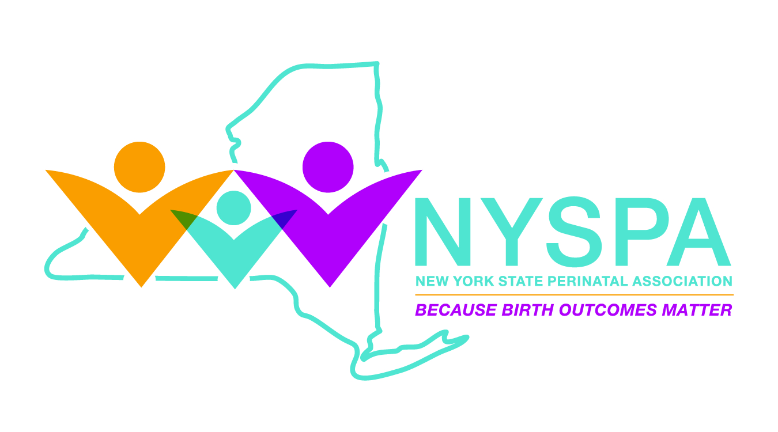

2023 L Stanley James Nomination

NAME: _____________________________________________TITLE: ________________________
Employer: _______________________________________________________________________
ADDRESS: ________________________________________________________________________
CITY: _________________________________________________ZIP: ________________________
PHONE: ___________________________________FAX: ___________________________________
E-MAIL ADDRESS: _________________________________________________________________
Submitted by (name) _____________________________________(phone) ___________________

Email: ______________________________Mailing Address: ________________________________

See https://nysperinatal.org/Stanley-James-Award-Nominations for guidance on the criteria for nominations.
The New York State Perinatal Association Recognition Awards are presented at the Annual Luncheon held during the NYSPA Perinatal Partnership Conference. June 8, 2023 @ the Hilton Hotel, Lodge St., Albany, NY.
Please provide examples of the nominee’s actions that supported the provision of, or access to reproductive, maternal and/or infant health care in New York State. You can also provide any additional letters of support from others explaining why the nominee deserves recognition as NYSPA’s 2023 L. Stanley James Award recipient. (Please limit submission to 1 - 2 pages)
If you have any questions regarding your nomination, please contact Sharon Chesna @ schesna@mothersnandbabies.org /607-725-4832, or LuAnne Brown @ lb@bppn.org /716-998-7426.

All nominations must be received by 5/1/2023 via email to: nyspa@nysperinatal.org with a cc: schesna@mothersandbabies.org.

